## VISVESVARAYA TECHNOLOGICAL UNIVERSITY

**“JnanaSangama”, Belgaum -590014, Karnataka.**



**PROJECT WORK-1 REPORT**

**on**

**COLLEGE ADMISSION REGISTRATION FORM**

***Submitted by***

**NIKHIL S.N (1BM19CS102)**

NITISH KUMAR .M **(1BM19CS107)**

**P PREM SAI (1BM19CS109)**

***Under the Guidance of***

|  |  |
| --- | --- |
| **Dr. Bhoomika A P**  **Associate Professor, BMSCE** |  |

***in partial fulfillment for the award of the degree of***

**BACHELOR OF ENGINEERING**

***in***

**COMPUTER SCIENCE AND ENGINEERING**



**B.M.S. COLLEGE OF ENGINEERING**

**(Autonomous Institution under VTU)**

**BENGALURU-560019**

**Sep-2020 to Jan-2021**

**B. M. S. College of Engineering,**

**Bull Temple Road, Bangalore 560019**

(Affiliated To Visvesvaraya Technological University, Belgaum)

**Department of Computer Science and Engineering**



**CERTIFICATE**

This is to certify that the project work entitled “**COLLEGE ADMISSION REGISTRATION FORM**” carried out by **NIKHIL S.N(1BM19CS102), NITISH KUMAR.M (1BM19CS107) AND P PREM SAI(1BM19CS109)**who arebonafide students of **B. M. S. College of Engineering.** It is in partial fulfillment for the award of **Bachelor of Engineering in Computer Science and Engineering** of the Visveswaraiah Technological University, Belgaum during the year 2020-2021. The project report has been approved as it satisfies the academic requirements in respect of **Project Work-1 (19CS3PWPW1)**work prescribed for the said degree.

Signature of the Guide                 Signature of the HOD

Dr. Umadevi V Dr. Umadevi V

Associate Professor Associate Prof.& Head, Dept. of CSE

BMSCE, Bengaluru BMSCE, Bengaluru

External Viva

Name of the Examiner                                                                                       Signature with date

1._____________________________ ________________________

2. _____________________________ _________________________

**B.M.S. College of EngineerinG**

**DEPARTMENT OF COMPUTER SCIENCE AND ENGINEERING**



***DECALARATION***

We,NIKHIL S.N (1BM19CS102), NITISH KUMAR.M (1BM19CS107) andP.PREMSAI (1BM19CS109) studentsof 3rd Semester, B.E, Department of Computer Science and Engineering,B. M. S. College of Engineering, Bangalore, herebydeclare that, this Project Work-1entitled "COLLEGE ADMISSION REGISTRATION FORM" has beencarried out by us under the guidance of Dr.UmadeviV,Associate Professor, Department of CSE, B. M. S. College of Engineering,Bangalore during the academic semester Sep-2020-Jan-2021

We also declare that to the best of ourknowledge and belief, the developmentreported here is not from part of any otherreport by any other students.

Signature

NIKHIL S. N (1BM19CS102)

NITISH KUMAR .M (1BM19CS107)

P PREM SAI (1BM19CS109)

FLOW CHARTOF

WEBPAGE

LOGIN PAGE

ADMIN STUDENT

ADMIN PAGE HOME PAGE

KNOW ABOUT REGISTER NOW

BMSCE

STUDENT DETAILS

COLLECTION PAGES

1.Introduction:

Website development for “College Admission Registration”

This online admission registration supports the following users

a. Student.

b. College admission team.

Functionalities under student login:

1.Can register for admission for college through registration form.

2.Can know more information about the college .

Functionalities for college admission team:

1.Can know about the students who has admitted to college.

2. Number of students in courses can be known.

2.Design layouts: Screen Shots of Webpage

2.1:Student Login webpage-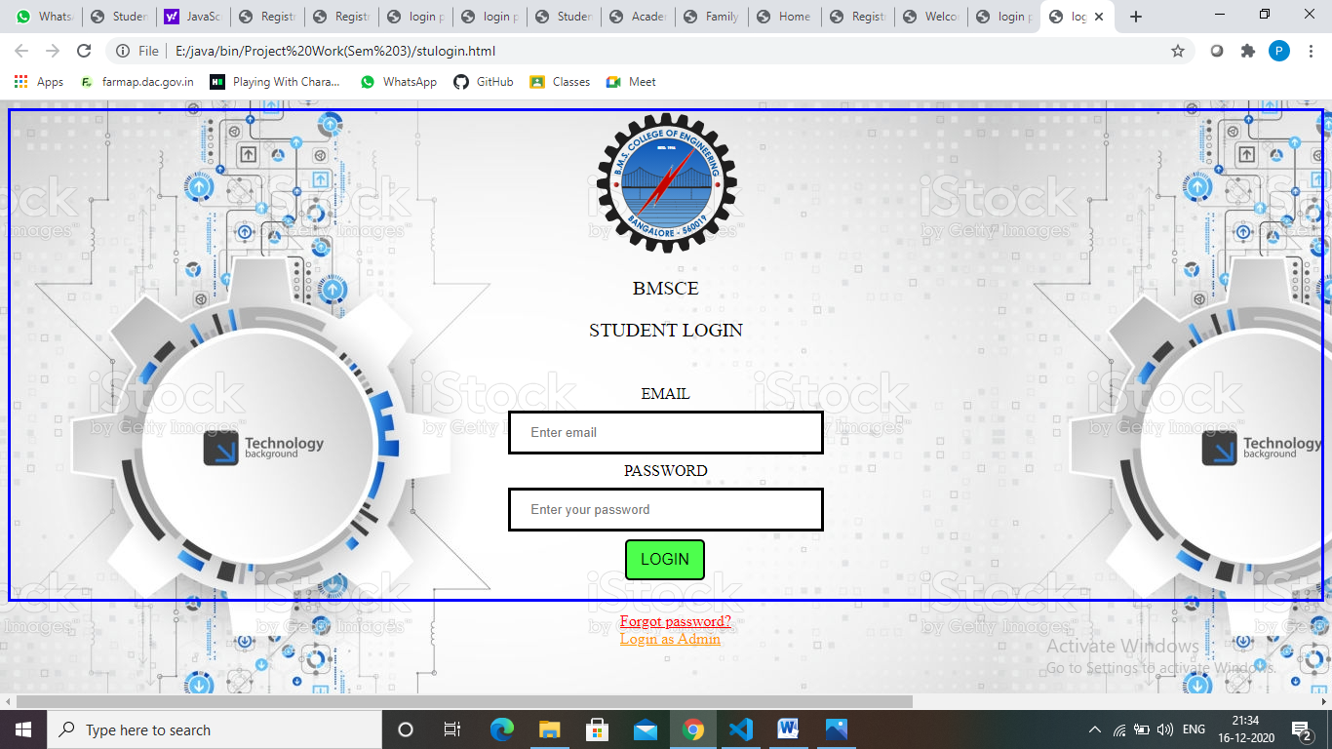

**2.2 : Student Forgot Password**

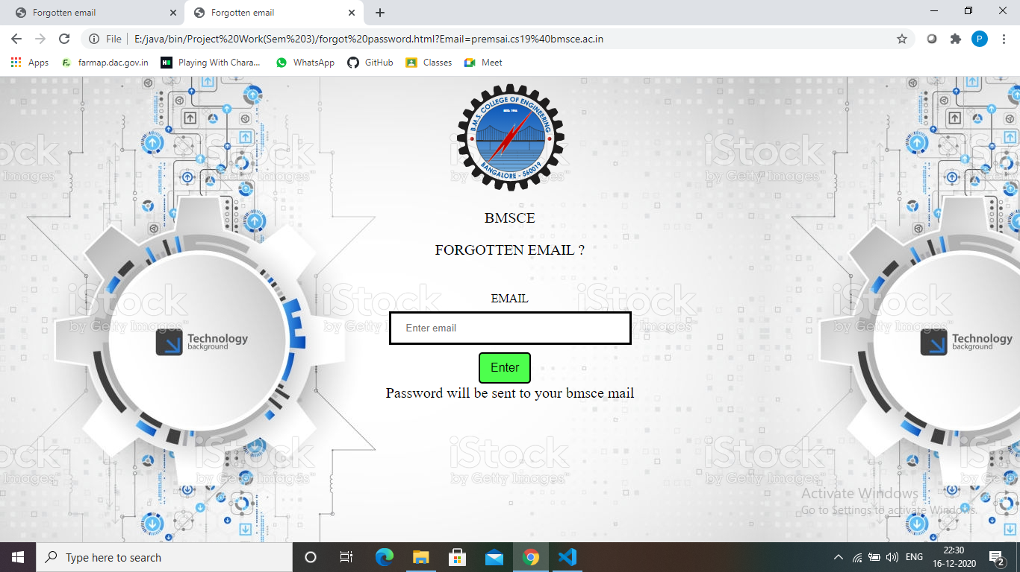

2.3: Home Webpage



2.4: Student Personnel Details page

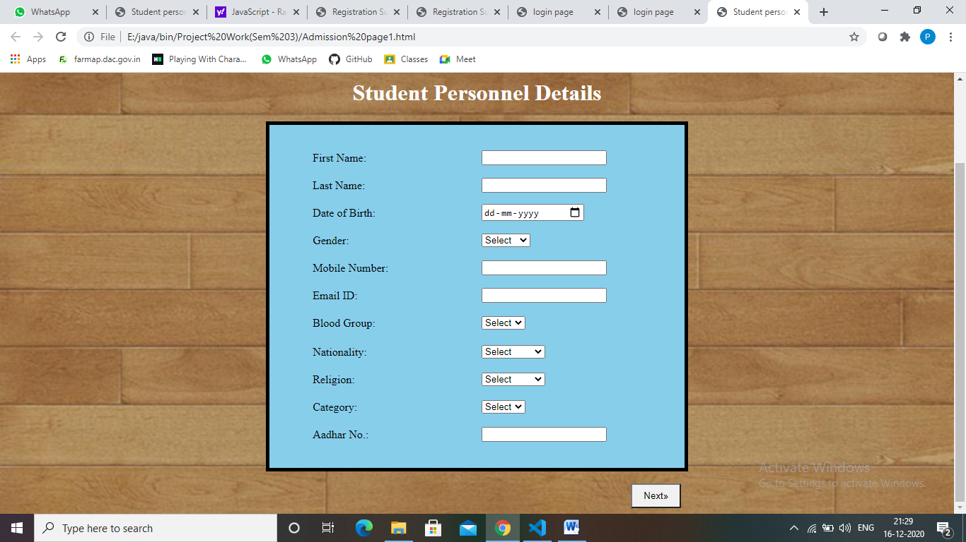

2.5: Student Academic Details page

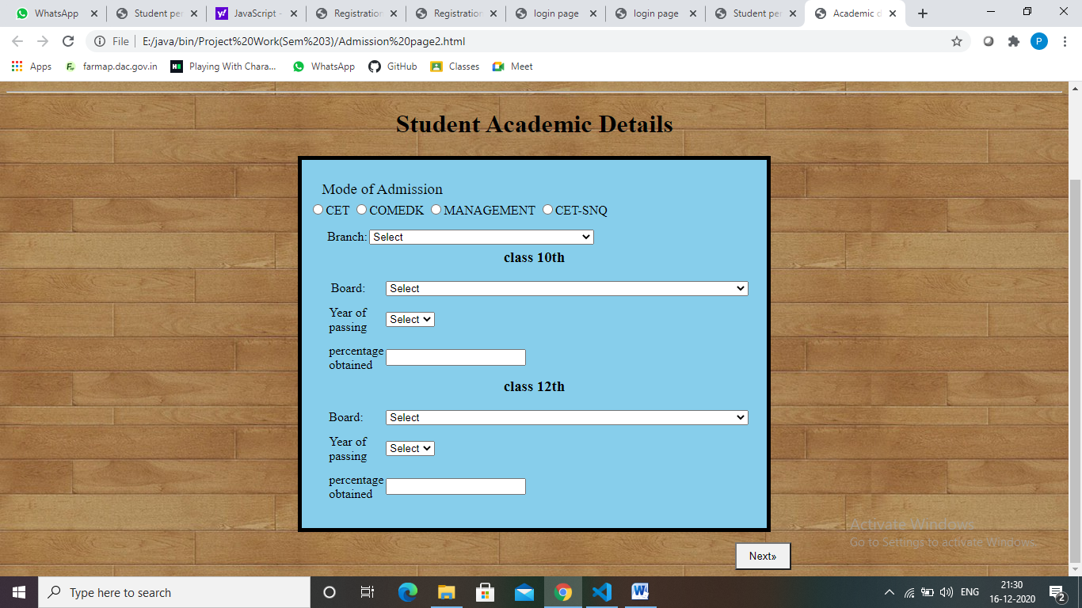

2.6: Family Particulars page

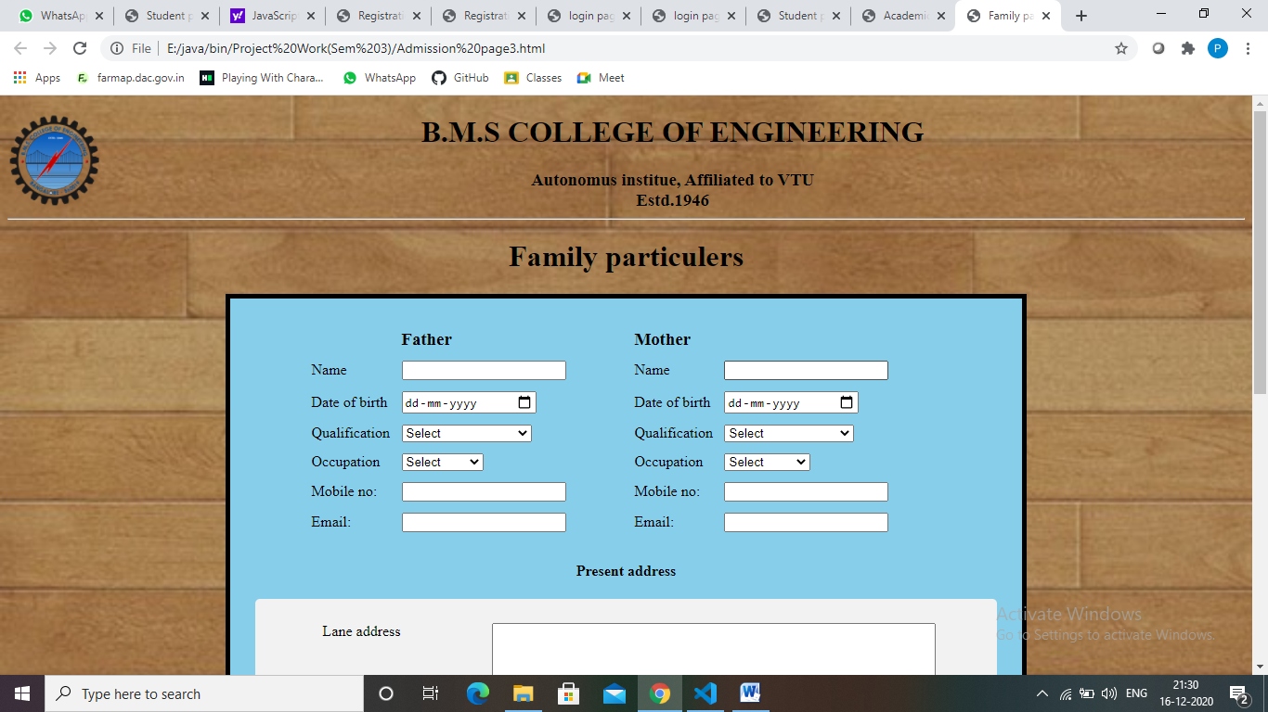

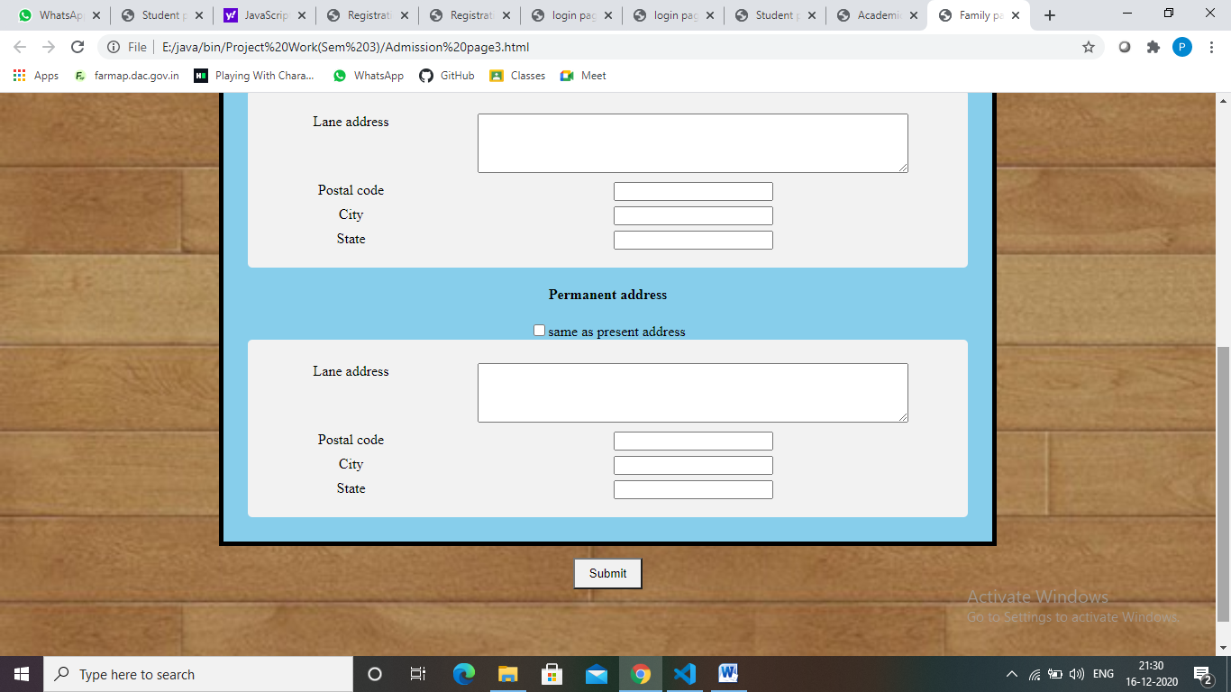

2.7: Registration successful page

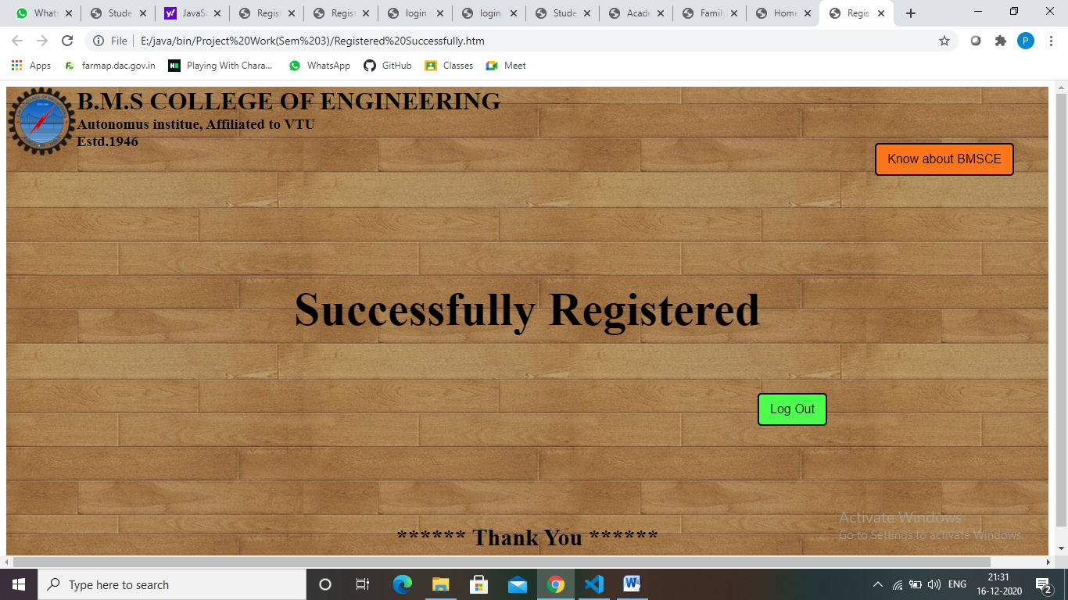

**2.8 : Admin Login webpage**

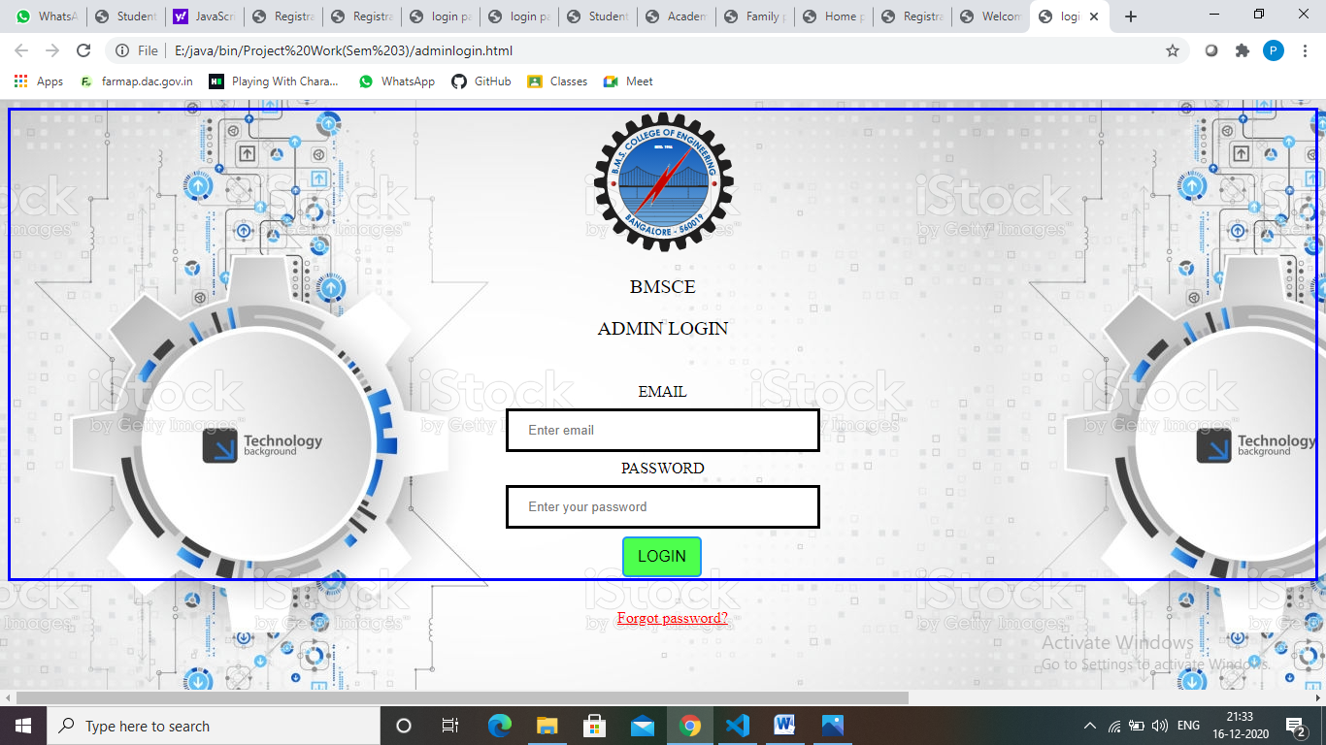

**2.9 :Admin Forgot Password**



**2.10 : Admin webpage**

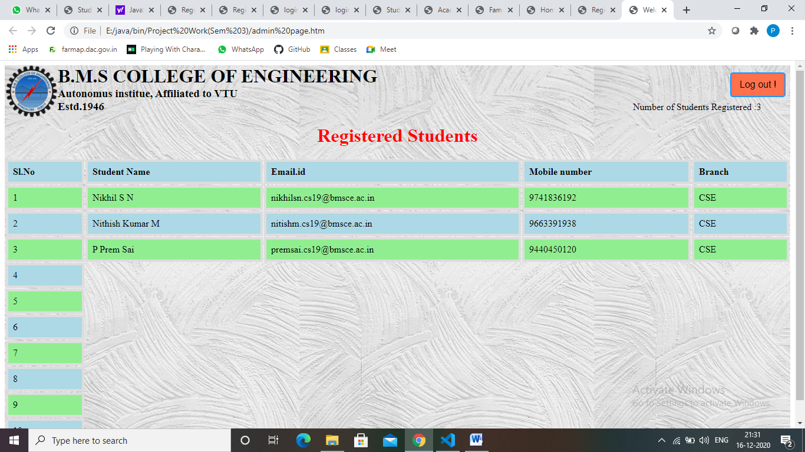

***THANK YOU***